Email template – Healthy Habits
Subject: Work on Healthy Habits this October
October at LifeCheck is all about healthy habits. And that also means Stoptober is back! A month in which thousands of people across the country try to quit smoking together. It’s a powerful nationwide initiative, and we’re here to support you along the way.
But… Stoptober isn’t just about quitting smoking.
It’s also a great opportunity to take a closer look at your own (un)healthy habits. Maybe you want to move more, eat healthier, snack less, sleep better, or take more breaks at work. Whatever your goal, small steps can make a big difference.
Easily track your habits
Want to get started but not sure how? These three simple steps can help you on your way:
- Observe your week
For a few days, note what you eat, how much you move, how you sleep, and when you feel stressed. This gives you an honest picture of your daily routine.
- Choose a small goal
For example:
Take a 10-minute walk every day
Eat one extra piece of fruit
Smoke one less cigarette per day
Go to bed on time once a week
- Make it specific, achievable, and write it down
Formulate your goal positively and measurably. Write it on a piece of paper and place it somewhere you see it every day:
"I take a 10-minute walk after lunch on workdays."
Extra support from LifeCheck
We all know smoking isn’t good for you, but quitting can be tough. LifeCheck coaches can support you with a quitting plan. With professional guidance and practical tools, you’ll increase your chances of lasting success.
Are your healthy habits related to nutrition or exercise?
Our specialists can help:
Dietitians can give advice on nutrition that suits your body and goals.
The Get Fit program provides practical tips to move more and gradually improve your fitness.
Visit the LifeCheck platform to schedule an appointment via the app or website: www.lifeCheck.nl
Not signed up for LifeCheck yet?
- Visit https://startjouw.lifecheck.nl/ or download the LifeCheck app using the QR codes.
- Create your account using a one-time activation code: EMPLOYERNAME-yourstaffnumber (for example, ROBIDUS-012345). Tip: You can find your staff number on your payslip.
- That’s it! You’re ready to start exploring consultations, coaching, and lifestyle programs right away.
Check out these videos to see how to register via the app or via the website
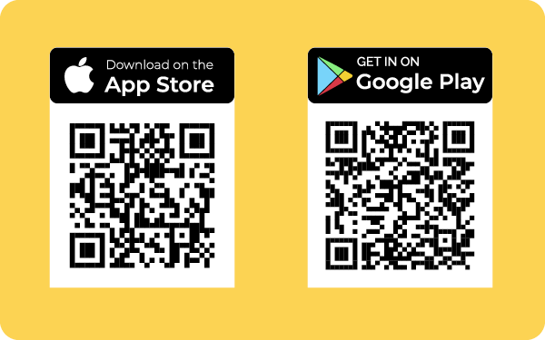
Your privacy is completely safe. We only use your data to log you in. Everything you do in LifeCheck stays private and secure.

